Club activities
FIRE ANNUAL REPORT

- THE ICEBREAKER DATE: 16th July, 2019 VENUE: Capitanio Hall

The icebreaker consisted of a game of charades but with the twist of enacting economic terms. It was indeed very engaging and fun, and greatly helped everyone get to know each other as well as the club.

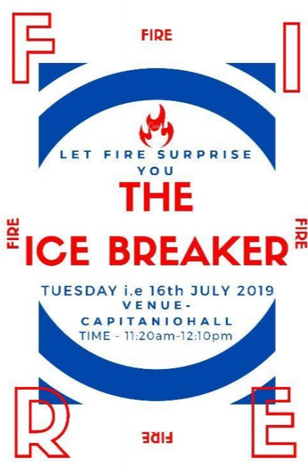
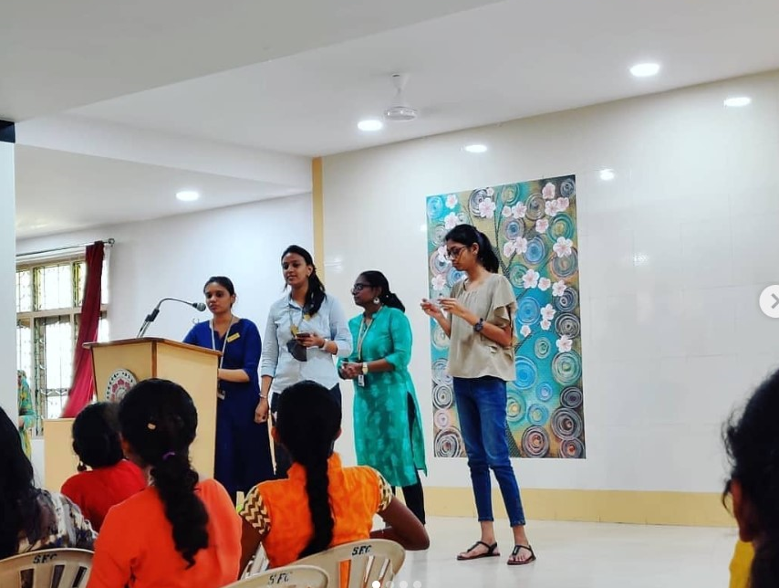
- ACT TO SOLVE DATE: 5TH August, 2019 VENUE: Capitanio Hall

Water crisis, encephalitis and income inequality were some of the many topics that the students tackled in the “Act to Solve “event. The ten teams presented various issues in the form of a skit while also providing possible solutions to curb these problems.

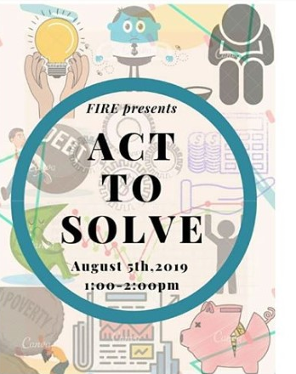
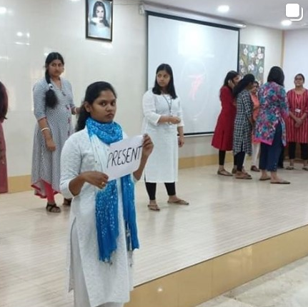
- RADDHI
DATE: 7th August, 2019 VENUE: Indoor Stadium
Raddhi is an important event conducted annually by the FIRE club. It involved the ten teams competing against each other in collecting the most scrap which includes newspapers, plastics, books and e-waste including wires and cables.
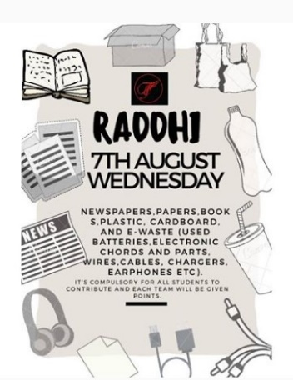
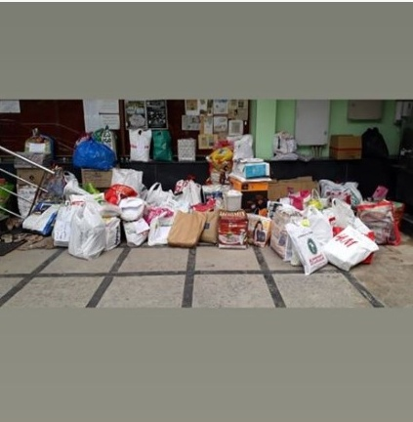
- GUEST LECTURE ON DIGITAL BANKING DATE: 9th September, 2019
VENUE: Capitanio Hall
The speaker for the lecture was Vijayalakshmi Muddu who currently is the Deputy General Manager and Senior Faculty at the State Bank Institute for Consumer Banking.

In her lecture, Ms Vijayalakshmi started off by talking about the digital world in general, its merits and demerits and then transitioned into digital banking; the banking sector in the SBI and new e-services within the sector. Ms Vijayalakshmi left the students with a lot more knowledge and awareness about the world of digital banking.
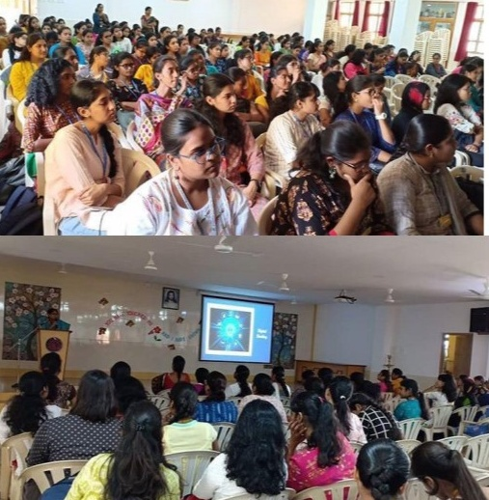
- AGNI

DATE: 3rd December, 2019
VENUE: Auditorium

Agni, the annual intra-college fest of FIRE was organized on the 3rd of December, 2019. It marked yet another successful annual event for FIRE where in participants engaged in a variety of competitions. The competitions were designed in such a way that students with some knowledge of economics could participate. Offline competitions included face painting, nostalgic games, guess the price and human chess while online competitions ranged from photography to meme making.
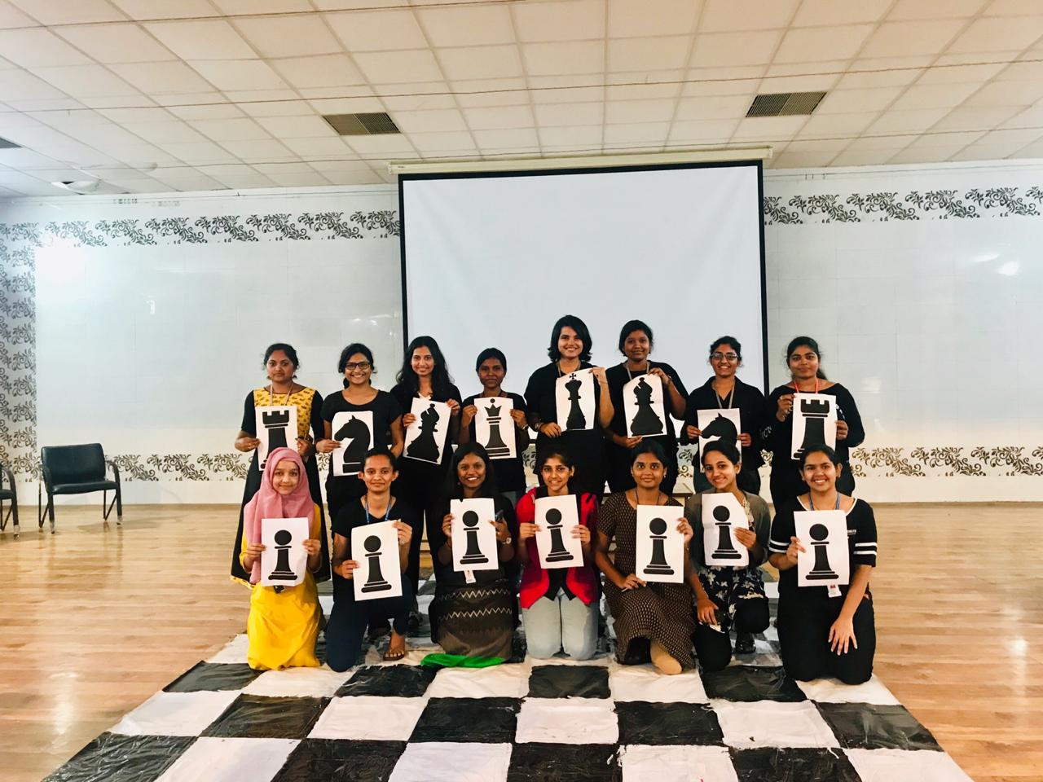
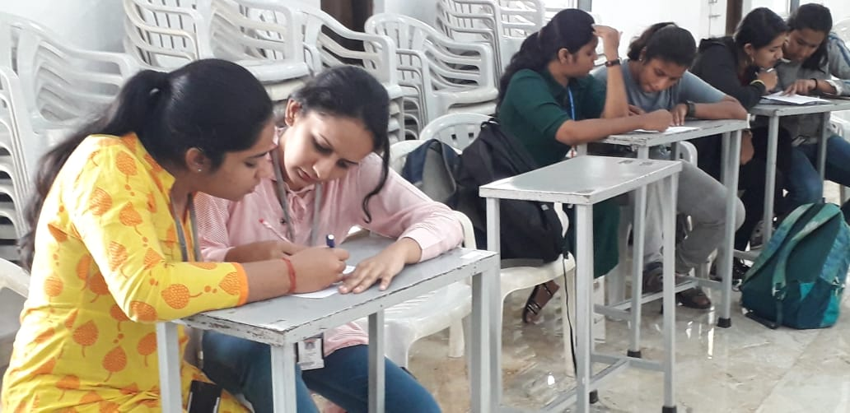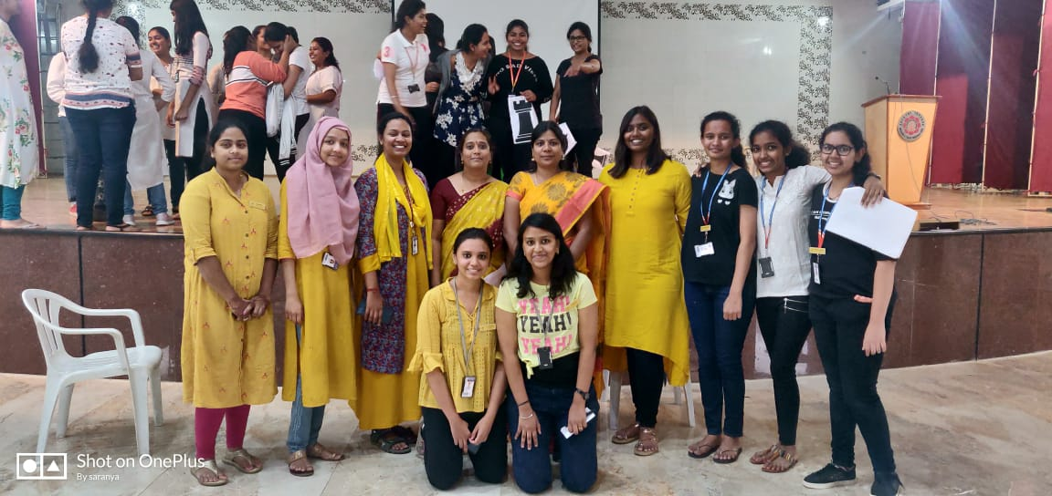
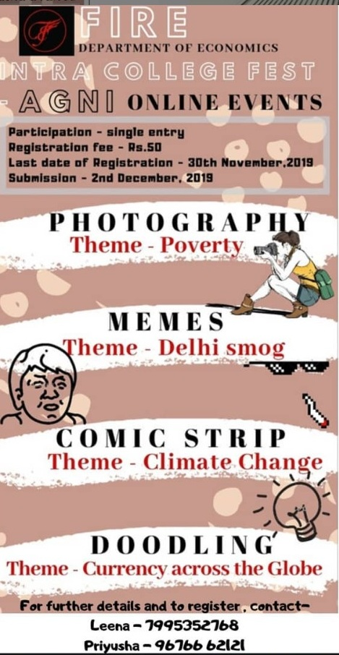
- KNOW YOUR ECONOMY TEST

DATE: 11th February, 2020
VENUE: Capitanio Hall

The ‘Know Your Economy’ test is a competition conducted by the Scientific Research Association for Economics and Finance, Chennai. The participants receive prior material which greatly helps increase their basic economic knowledge.
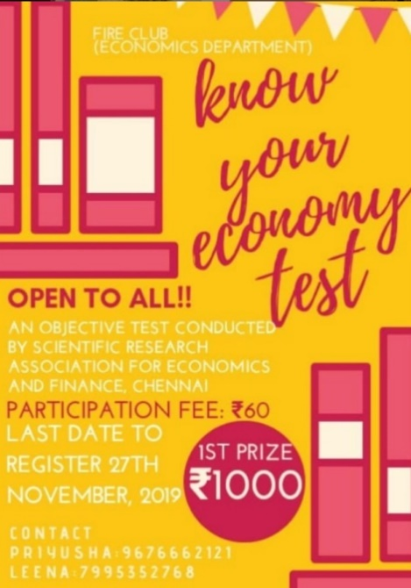
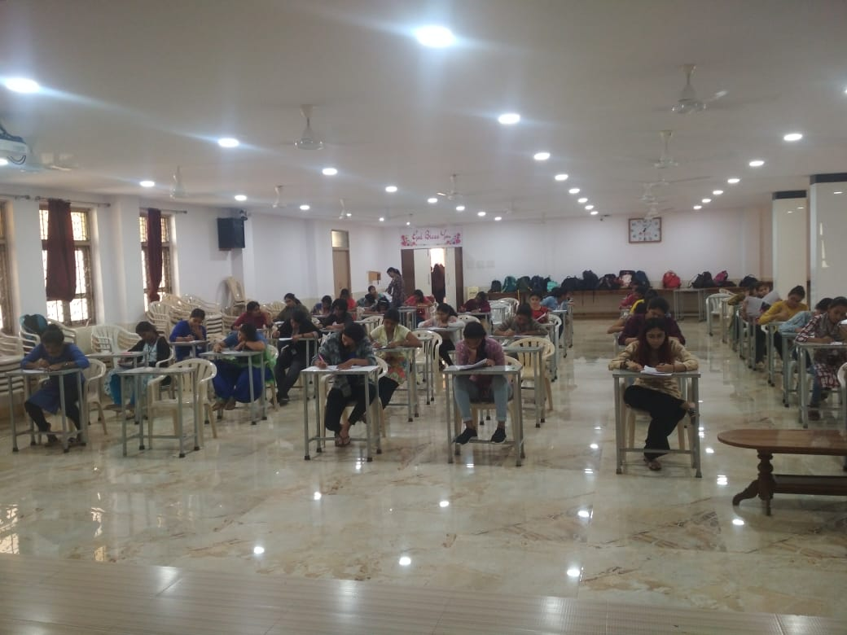

- SOFTBOARD COMPETITION

All the ten groups in FIRE club were engaged in the competition throughout the year where they covered current happenings in the field of Economics and creatively put it on the board.
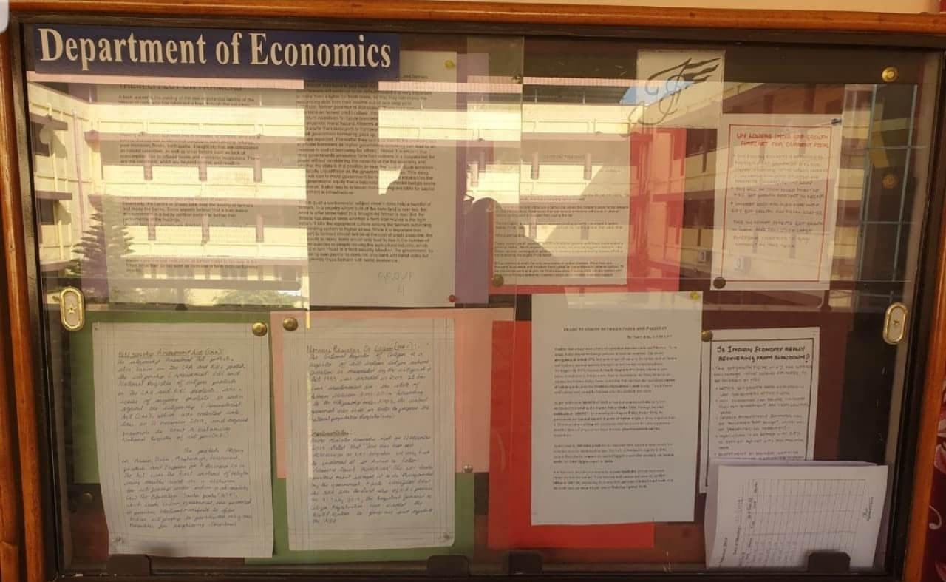
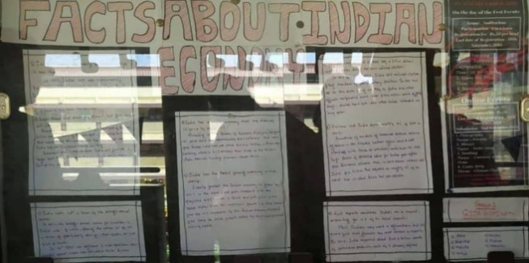
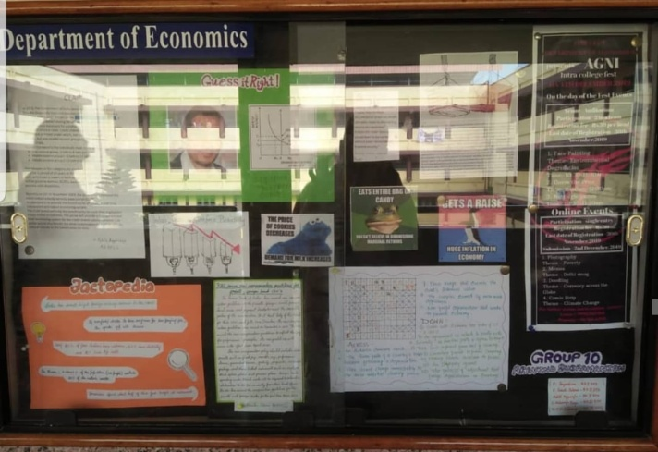
- INSTAGRAM PAGE

The Club has started its own Instagram page to keep the students updated about various aspects of economics from around the world.





